Bewick, Thomas [1753–1828]. A History of British Birds. The Figures Engraved on Wood by T. Bewick. Vol. 1. Containing the History and Description of Land Birds [text by Ralph Beilby] / Vol. 2. Containing the History and Description of Water Birds [text by Thomas Bewick and Henry Cotes]. Newcastle: Printed by Edward Walker, for T. Bewick; London: Longman & Co., 1816.
— https://www.thebrontes.net/reading/bewick
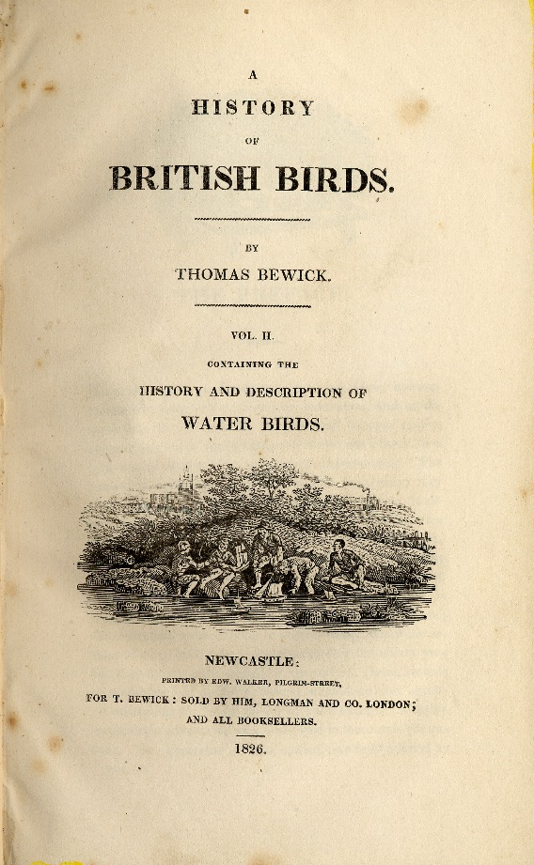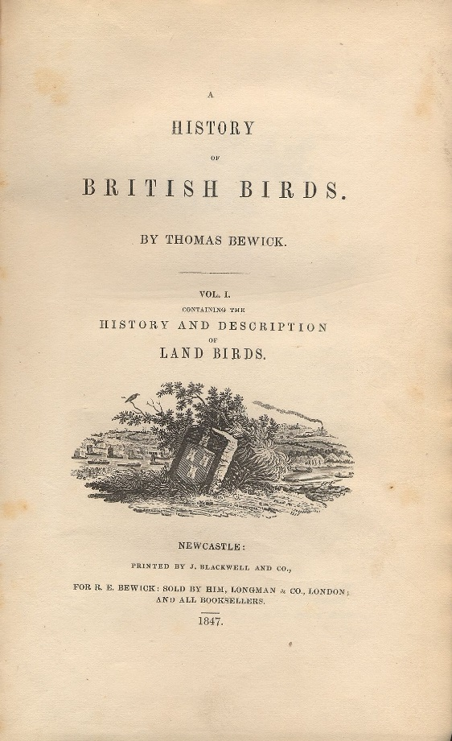

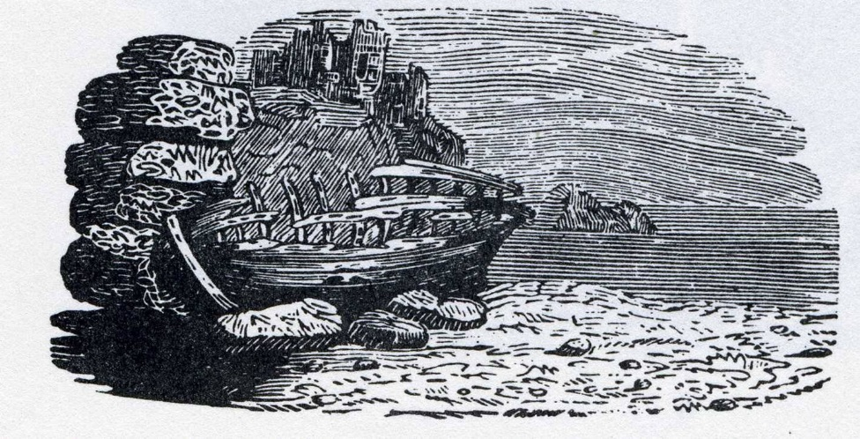
“I cannot tell what sentiment haunted the quite solitary churchyard with its inscribed headstone; its gate, its two trees, its low horizon, girdled by a broken wall, and its newly-risen crescent, attesting the hour of even-tide. The two ships becalmed on a torpid sea, I believed to be marine phantoms.The fiend pinning down the thief’s pack behind him, I passed quickly: it was an object of terror.” (Jane Eyre, Chap. 1.)

